

**Authors**

Maqsood Ahmad

(01-134132-DD088)

S.M Sameed Arshad

(01-134132-183)

**GAIT ANALYSIS APPLICATION**

Bachelors of Science in Computer Science

Supervisor: Sayed Khushal Shah

Department of Computer Science

Bahria University, Islamabad

November 21th, 2017

# 

# CERTIFICATE

We accept the work contained in this report as a confirmation to the required standard for the partial fulfillment of the degree of BS (CS).

\_\_\_\_\_\_\_\_\_\_\_\_\_\_\_\_\_\_ \_\_\_\_\_\_\_\_\_\_\_\_\_\_\_\_\_\_

Head of Department Supervisor

\_\_\_\_\_\_\_\_\_\_\_\_\_\_\_\_\_\_ \_\_\_\_\_\_\_\_\_\_\_\_\_\_\_\_\_\_

Internal Examiner External Examiner

# 

# 

# DEDICATION

This work is dedicated to my parents and teachers. Without their support we would not have been able to complete this project. We have been lucky enough to get the support from our family members. Who provided us the resources to undertake this project. They have always remained a great source of motivation for us.

Special thanks to our project supervisor Sayed Khushal Shah who continuously guided us during the course of this project. His technical assistance, guidance and support helped us acquire the theoretical concepts and the development skills required to complete this project. Without his guidance, we would not have been able to achieve the desired results.

Last but not the least we would like to thank our friends & class mates who helped us a lot during this project.

# 

# Acknowledgement

We are grateful to our almighty Allah for the good health and well being that were necessary to complete our report.

We want to thanks our supervisor Sir Sayed Khushal Shah for his help throughout the project cycle, without his help it would not been possible to complete this project or to achieve our goal.

We take this opportunity to express gratitude to all the faculty members of the department of copter science for their help and support. We also thanks to our parents for everything they did for us especially for their prayers and endless love.

“We think someone else, someone smarter than us, someone more capable; someone with more resources will solve that problem. But there isn’t anyone else”

Regina Dugan

Contents

[CERTIFICATE ii](#_Toc499666503)

[DEDICATION iii](#_Toc499666504)

[Acknowledgement iv](#_Toc499666505)

[Chapter 1 1](#_Toc499666506)

[Introduction 1](#_Toc499666507)

[1.1 Project Background &Overview: 2](#_Toc499666508)

[1.2 Objective 2](#_Toc499666509)

[1.3 Scope of the project 2](#_Toc499666510)

[1.4 Problem description 3](#_Toc499666511)

[1.5 Methodology 3](#_Toc499666512)

[1.6 Final Deliverable 3](#_Toc499666513)

[1.7 Risks: 3](#_Toc499666514)

[1.7.1 Risk involved: 3](#_Toc499666515)

[1.7.2 Resource requirement 3](#_Toc499666516)

[1.8 Expertise of team member 4](#_Toc499666517)

[1.9 Tools/Technology 4](#_Toc499666518)

[Chapter 2 5](#_Toc499666519)

[LITERATURE REVIEW 5](#_Toc499666520)

[2.1 Related Work: 6](#_Toc499666521)

[2.2 Proposed Solution: 6](#_Toc499666522)

[Chapter 3 7](#_Toc499666523)

[REQUIREMENT SPECIFICATION 7](#_Toc499666524)

[3.1 Purpose of Document 8](#_Toc499666525)

[3.3 System Overview and Scope 8](#_Toc499666526)

[3.4 Operating Environment 8](#_Toc499666527)

[3.5 Constraints, Assumptions and Dependencies 8](#_Toc499666528)

[3.6 Functional Requirements 9](#_Toc499666529)

[3.7 Non-functional Requirements 9](#_Toc499666530)

[3.8 Availability 9](#_Toc499666531)

[3.9 Efficiency 9](#_Toc499666532)

[3.10 Time Factor 9](#_Toc499666533)

[3.11 Productivity 9](#_Toc499666534)

[3.12 Reliability 10](#_Toc499666535)

[3.13 User Interface and Human Factors 10](#_Toc499666536)

[Chapter 4 11](#_Toc499666537)

[System Design 11](#_Toc499666538)

[4.1 Use Cases 12](#_Toc499666539)

[4.2User Reading Hospital Generating Data 13](#_Toc499666540)

[4.3 User Storing Gait Data in Text File 13](#_Toc499666541)

[4.4 Reading Gait Data Text File 14](#_Toc499666542)

[4.5 System Computing Mean Value 14](#_Toc499666543)

[4.6 System Computing the Deviation 15](#_Toc499666544)

[4.7 Computation of Final Values 15](#_Toc499666545)

[4.8 Matching Final value with threshold 16](#_Toc499666546)

[4.9 Evaluate Patient Status 16](#_Toc499666547)

[4.10 FLOW DIAGRAM 17](#_Toc499666548)

[4.10.1 Reading Control Data 18](#_Toc499666549)

[4.10.2Reading ALS (Amyotrophic lateral sclerosis) Data 18](#_Toc499666550)

[4.10.3 Reading HUNT (Huntington’s) Data 19](#_Toc499666551)

[4.10.4 Reading PARK (Parkinson’s) Data 19](#_Toc499666552)

[4.10.5Computations 20](#_Toc499666553)

[4.10.6 Matching with Threshold values 21](#_Toc499666554)

[4.10.7 Patient Status 22](#_Toc499666555)

[Chapter 5 23](#_Toc499666556)

[Implementation 23](#_Toc499666557)

[5.2 System Architecture: 26](#_Toc499666558)

[5.2 Software Components: 26](#_Toc499666559)

[5.3 Tools Used 26](#_Toc499666560)

[5.4 Developer Tools: 26](#_Toc499666561)

[5.4.1 Programming Languages: 26](#_Toc499666562)

[5.4.2 MS Office: 26](#_Toc499666563)

[5.4.3 Spiral Team: 26](#_Toc499666564)

[For the project plan and schedule and tracking of requirements 26](#_Toc499666565)

[5.5 Main Menu: 27](#_Toc499666566)

[5.5.1 Description 27](#_Toc499666567)

[5.6 By clicking Step 1: 27](#_Toc499666568)

[5.6.1 Description: 27](#_Toc499666569)

[5.7 By clicking on Show result: 28](#_Toc499666570)

[5.7.1 Description: 28](#_Toc499666571)

[5.8 By clicking on Browse: 28](#_Toc499666572)

[5.8.1Description 28](#_Toc499666573)

[5.9 By clicking on the Report button: 29](#_Toc499666574)

[5.9.1 Description 29](#_Toc499666575)

[Chapter 6 30](#_Toc499666576)

[System Testing and Evaluation 30](#_Toc499666577)

[6.1 Test Cases: 31](#_Toc499666578)

[6.1.1 Analysis Phase 31](#_Toc499666579)

[6.1.2 Result Generating Phase 32](#_Toc499666580)

[6.1.3 If the Step 1 Button won’t be pressed 33](#_Toc499666581)

[6.1.4 Result Display True Case 34](#_Toc499666582)

[6.1.5 Result Display False case 35](#_Toc499666583)

[6.1.6 File Upload Success Case 36](#_Toc499666584)

[6.1.7 File Upload False Case 37](#_Toc499666585)

[6.1.8 Disease Diagnose 38](#_Toc499666586)

[6.1.9 Status of Patient when provided the normal patient gait data 39](#_Toc499666587)

[6.1.10 Normal Patient Data False Acceptance 40](#_Toc499666588)

[6.1.11 ALS patient data False Acceptance 41](#_Toc499666589)

[6.1.12 ALS Patient data success case 42](#_Toc499666590)

[6.1.13 HUNT Patient Data Success Case 43](#_Toc499666591)

[6.1.14 HUNT Patient Data False Acceptance 44](#_Toc499666592)

[Chapter 7 46](#_Toc499666593)

[CONCLUSION 46](#_Toc499666594)

[7.1 CONCLUSION: 47](#_Toc499666595)

[7.2Future Recommendations 47](#_Toc499666596)

[REFERENCES 48](#_Toc499666597)

# Chapter 1

# Introduction

## Project Background &Overview

Different peoples interest in different fields depending on the field of interest. For instance, for security purposes, interest may centre on distinguishing and identifying persons based on a general characterization of their silhouette and the movements between the subject's different body segments when walking. However in the field of sport, research may centre on analysis the different forces exerted on each muscle through EMG. From the clinical point of view, the importance of human gait analysis lies in the fact that gait disorders affect a high percentage of the world’s population and are key problems in neurodegenerative diseases such a multiple sclerosis, amyotrophic lateral sclerosis or Parkinson’s disease.

We are familiar that there are a lot of diseases in people by birth or in the result of any accident or mishap. They become paralyzed for the rest of their lives and they totally depend on other people. And the treatment and tests for these diseases are very expensive and out of reach for the middle class people, lower middle class peoples. So there should be an application or system by the help of which we can predict the disease of the person in the best efficient way. [[1](#_REFERENCES_1)]

We are also familiar that in foreign countries like Russia, china and Japan these countries are very advance in technologies. As they care about the human life more than anything they have developed advance system for gait diseases. And they offer free treatment for the people who are suffering from such type of diseases. We have all the technology to cure and determine the gait diseases but the treatment is very expensive and out of reach of middle\lower class.

In sports, competition is increasing and it is remain impossible for the players to remain fit. To prevent from different diseases the player looking for the software which he measure the angle of the foot to remain fit.

## Objective

The objective of designing this system is to provide a platform for the doctors to record the walking style of the patients and diagnose disease in patients.

## Scope of the project

The scope of this project is very vast that it can be used in by the army hospitals for determining the severity of the disease. Our system can also provide the service to the poor peoples who can’t afford the expensive tests for gait diseases.

## Problem description

* In case of any road accident if somebody hurt his/her lower body and is not able to walk properly our system can help him/her by determining the severity of disease.
* Many polio cases come in current days. To find out the severity of the disease we can use out system to diagnose disease.
* In sports, gait analysis can be use to improve athlete’s performance and injury prevention.

## Methodology

This Application development will use sequence of phases.

* In first phase we gather requirements for system by observing the existing systems and gathering requirements from the users mostly patients and law enforcement institutions.
* After this requirement gathering the actual system designing will starts under the consideration of these requirements.
* First, we develop Interface which contains Menu, for interaction with user, and then we design the main system by applying algorithms.
* In the third phase we collect the data using sensors and we design an algorithm so that we can predict the disease.

## Final Deliverable

* Desktop Application
* Project Report

## Risks:

### Risk involved:

* + **Organizational and management risks:**

If we are unable to follow our set timeline and fall short of any resources then project may not be end on time. Going from computer science to medical site, it is difficult to understand gait disease from every aspect and incase collect one wrong data the total disease type display wrong.

* + **Technical risks:**
* Two people have same walking style.
* Many chances of personal error.
* Difficult project modules integration.

### Resource requirement

* For data collection user should have the contacts in hospitals.
* User must have to meet minimum hardware requirements to play.

## Expertise of team member

We have a firm grip on all the aspects of the projects which includes different languages and software. We have already learnt the basic expertise required for this project, such as C#, MATLAB, C ++.

## Tools/Technology

* C#
* Visual Studio 2012
* MATLAB

# 

# Chapter 2

# LITERATURE REVIEW

## 

## 2.1 Related Work

Gait diseases are very common these days and most of the people are victim of this disease in Pakistan. As there is no proper prediction or recognition of gait diseases in Pakistan. The peoples who are suffering from these diseases spend their whole life depending on others and most of our peoples belong to middle and lower class families and they cannot afford the treatment and tests for the gait diseases.

Another big problem in Pakistan is increasing rate of POLIO patients. People in villages don’t pay enough attention towards the polio drops and because of this reason they suffer from very severe disorder. Treatment of this disease is very expensive in Pakistan and normal people can’t afford the treatment. The test for this polio disease do not gives accurate results and is not efficient. And mostly people spend their miserable life on bed.

Most professional’s athletes have a significant restriction in their ankle dorsiflexion range of motion which causes the heel of the foot to rise early and for a prolonged time. Foot and ankle injuries are extremely common among athletes and other physically active individuals. When an injury to the foot or ankle occurs athletes are limited in their abilities to run, jump, kick, and change directions.

## 2.2 Proposed Solution

The system we have designed is basically for the people belonging to middle\lower class families who can’t afford this expensive treatment of the gait disease. Our system is efficient enough to predict and determine the gait diseases in the people. Our system will help and facilitate such people in generating the test report of gait thus saving them a lot of money, spending on the expensive test.

We have designed the system by the help of which we can use the data from the sensors which are on the patients\criminals body. Our system will provide the efficient and accurate result as compared to the existing system for curing as well as predicting the disease level. Law enforcement institution can also use our system to recognize the criminals by the way he\she walks.

Gait application is used in different sports departments to find the limits of the angles of the foot to resist injuries.

# Chapter 3

# REQUIREMENT SPECIFICATION

## 

## 3.1 Purpose of Document

The purpose of this document is to describe the detail of Gait analysis. This document is to explain the working, specification, functionalities, and constraints under which our system is designed. This document describes all functional and non-functional requirements of our system.

## 3.3 System Overview and Scope

Our system can be used in law enforcement institutions and different hospitals for predicting polio diseases in people suffering from polio. It can be used to caught criminals and terrorists by the help of their walking style. It can also be used for diagnosing disease in serious injuries occurs in accidents.

The gait application is developed by using the popular designing platform knows as Visual Studios. It allows you to write code in C#. The project uses C# scripts due to its robustness and also as we have experience in it. [[1](#_REFERENCES_1)]

## 3.4 Operating Environment

The following software components are required.

* Windows XP or later
* Visual Studio
* MATLAB

## 3.5 Constraints, Assumptions and Dependencies

* **Speed of system:**

The speed of calculating the value of the system is fast.

# 3.6 Functional Requirements

The functional requirements of the system are:

* System should provide maximum information with least complexity.
* System should provide flexible analysis functionality.
* System should be suitable for clinical purpose.
* System should diagnosis correctly (Minimum False acceptance).
* System should categorized and evaluate the status of the patient according to his/her gait data (device generated data).

## 3.7 Non-functional Requirements

* Opening and closing of the application will be efficient.
* The primary performance requirements are the speed of the application.

### 3.8 Availability

Any user can access this system without a username and a password. System is available for anyone who has his/her own gait parameterized data generated from the device or taken from the hospital.

### 3.9 Efficiency

The application provides reliability. Easy in understand and use. Users get all information info at single application which saves time. System will exactly and accurately diagnose the disease. User quickly gets the result.

### 3.10 Time Factor

The system saves the user’s time by providing information on application which instead would have taken a lot of time in diagnosing the disease. If you have available this software in your home you can easily find your result sitting in your home.

### 3.11 Productivity

Application gives us fast feedback using different parameters which is one of the most useful features of the system. It provides us very detailed report about the gait patient. It tells from report that patient is suffering from which disease or his/her report is normal.

### 3.12 Reliability

Our application is a desktop based application so it will not be dependent on the internet for usage and proper functionality. User can get result about the patient by using our application. There will be no fake result because all the results will be generated after a long analysis and reading the research papers about the gait analysis systems.

### 

### 3.13 User Interface and Human Factors

* Graphical user interface would be quiet simple and user friendly.
* As it is desktop application so need a computer/laptop.
* General naming conventions are used in this system.
* User can scroll through the results

# 

# Chapter 4

# System Design

### 4.1 Use Cases

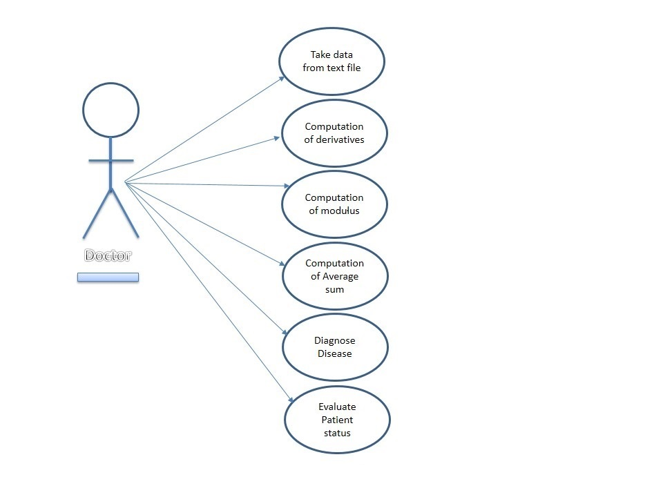

**Figure 4.1.Use Case 1**

# 

### 4.2User Reading Hospital Generating Data

**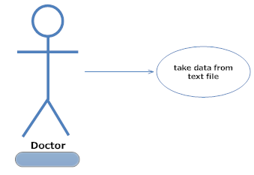**

**Fig 4.2 Reading Hospital Generated Data**

|  |  |
| --- | --- |
| USE CASE 1 | |
| NAME | Reading Hospital Generated Data |
| ACTORS | User |
| TYPE | Primary |
| DESCRIPTION | User will Read All the possible gait diseases data at most 30 t0 40 patient’s data that is Hospital Generated. |

### 4.3 User Storing Gait Data in Text File

**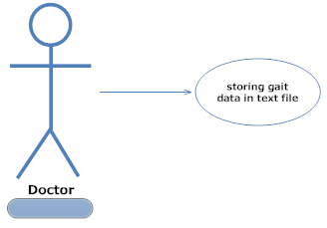**

**Fig 4.3 Storing gait data in text file**

|  |  |
| --- | --- |
| USE CASE 2 | |
| NAME | Storing Gait Data in Text File |
| ACTORS | User |
| TYPE | Primary |
| DESCRIPTION | Device Generated data has to be stored in text file with all its parameters Elapsed time, Left Stride, Right Stride, Left stance, Right Stance, Left Swing, Right Swing and Double Support. |

### 4.4 Reading Gait Data Text File

**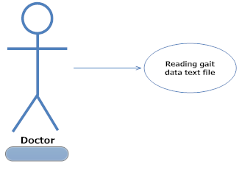**

**Fig 4.4 storing gait data in text file**

|  |  |
| --- | --- |
| USE CASE 3 | |
| NAME | Reading Gait Data Text File |
| ACTORS | User |
| TYPE | Primary |
| DESCRIPTION | Reading the Gait Data Text File to perform Analysis on it. |

### 4.5 System Computing Mean Value

**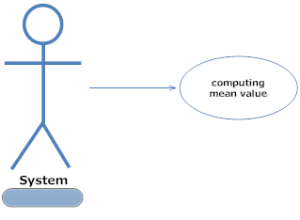**

**Fig 4.5 computing mean value**

|  |  |
| --- | --- |
| USE CASE 4 | |
| NAME | Computing Mean Values |
| ACTORS | System |
| TYPE | Primary |
| DESCRIPTION | After Reading The Gait Data Text File System will compute the Mean values of the Text File. |

### 4.6 System Computing the Deviation

**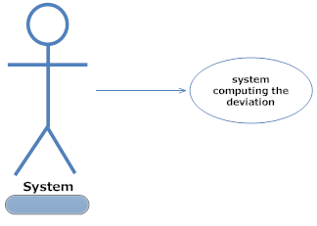**

**Fig 4.6 system computing the deviation**

|  |  |
| --- | --- |
| USE CASE 5 | |
| NAME | Computing the Deviation |
| ACTORS | System |
| TYPE | Primary |
| DESCRIPTION | After Computing the Mean Values of the Text File System will compute the Deviation values of the Text File. |

### 4.7 Computation of Final Values

**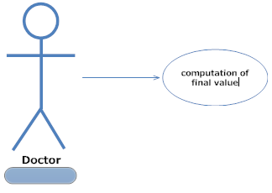**

**Fig 4.7 computation of final values**

|  |  |
| --- | --- |
| USE CASE 6 | |
| NAME | Computation of Final Values |
| ACTORS | User |
| TYPE | Primary |
| DESCRIPTION | After Computing Mean and Deviation System will generate the final values that will use to the categorized the patient status. |

### 4.8 Matching Final value with threshold

**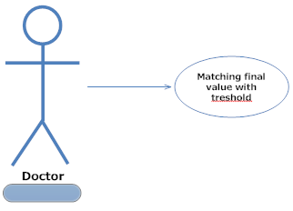**

**Fig 4.8 Matching final value with threshold**

|  |  |
| --- | --- |
| USE CASE 7 | |
| NAME | Matching Final Values with Threshold |
| ACTORS | User |
| TYPE | Primary |
| DESCRIPTION | Thresholds are the minimum and maximum range in which the patient gait data will exists. |

### 4.9 Evaluate Patient Status

**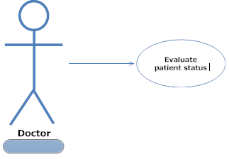**

**Fig 4.9 Evaluate patient status**

|  |  |
| --- | --- |
| USE CASE 8 | |
| NAME | Evaluate Patient Status |
| ACTORS | User |
| TYPE | Primary |
| DESCRIPTION | System will tell the Status of the Patient whether it is in ALS, PARK, and HUNT or in Control Category. |

### 4.10 FLOW DIAGRAM

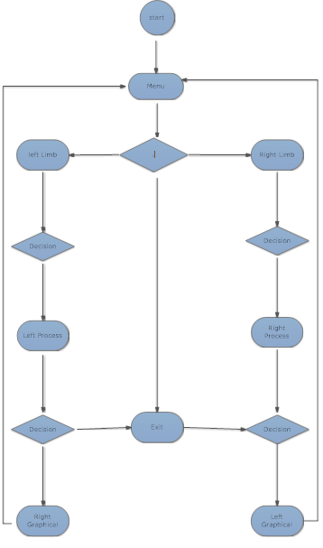

### 4.10.1 Reading Control Data

**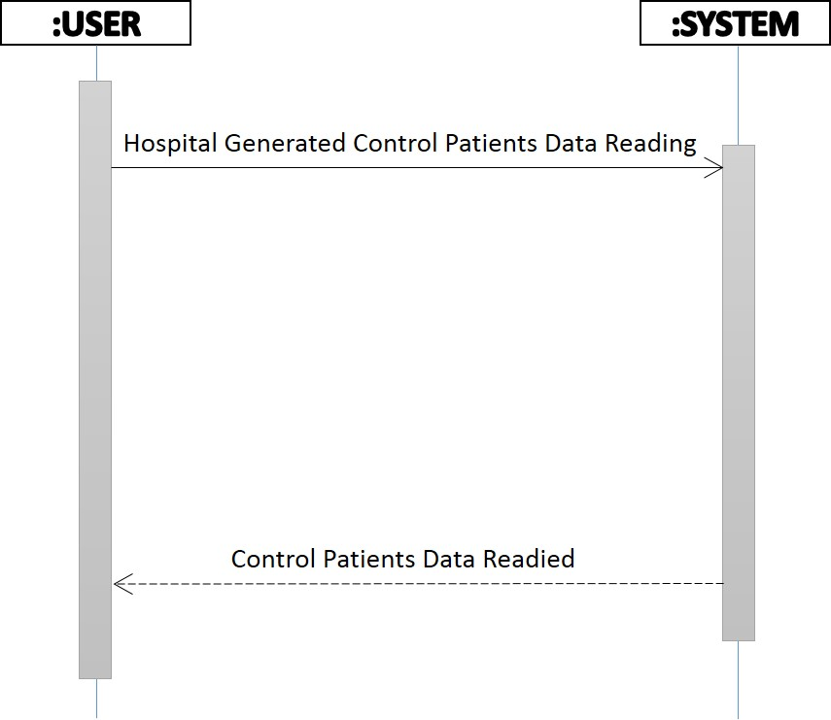**

### 4.10.2Reading ALS (Amyotrophic lateral sclerosis) Data

**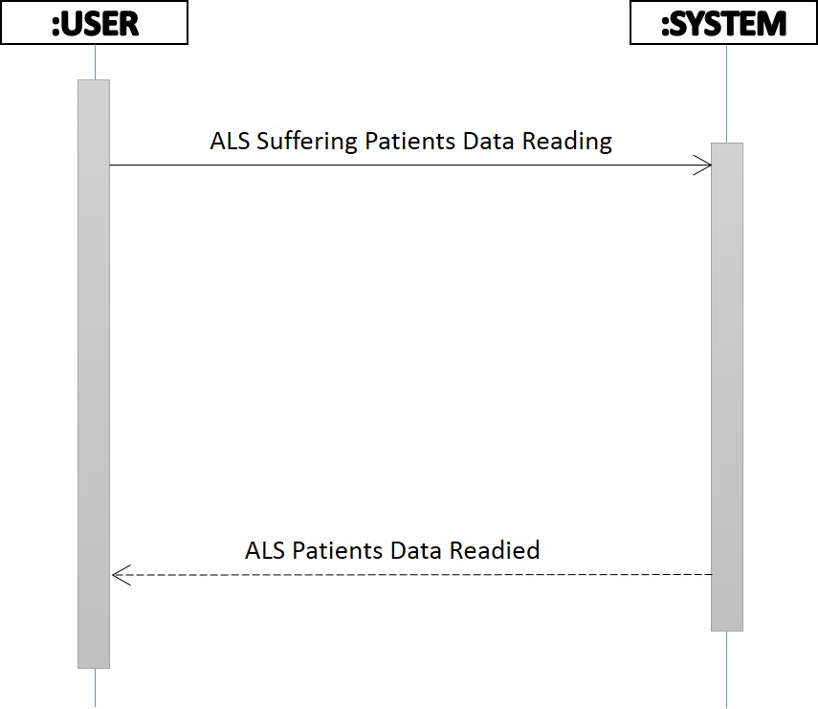**

### 4.10.3 Reading HUNT (Huntington’s) Data

**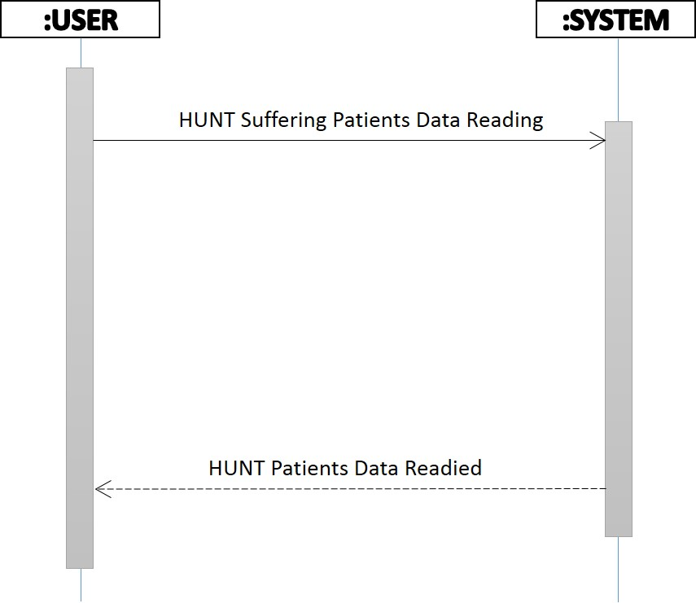**

### 

### 4.10.4 Reading PARK (Parkinson’s) Data

**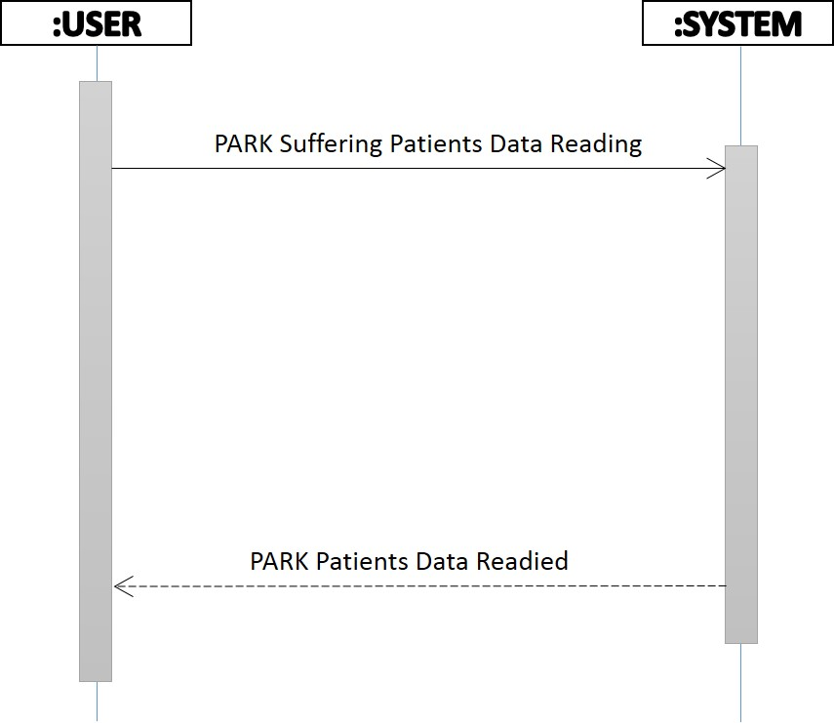**

### 4.10.5 Computations

**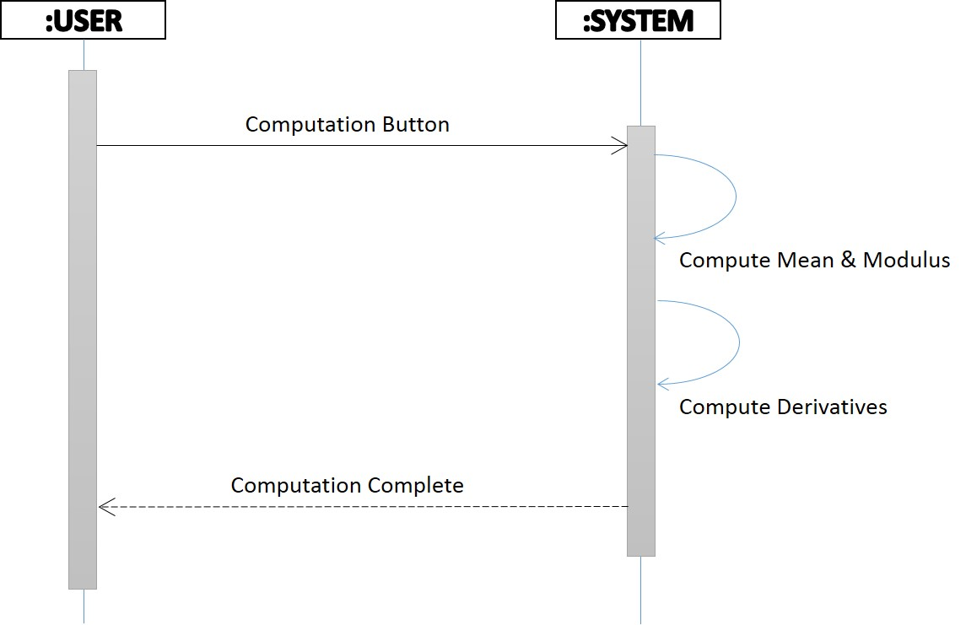**

### 

### 4.10.6 Matching with Threshold values

**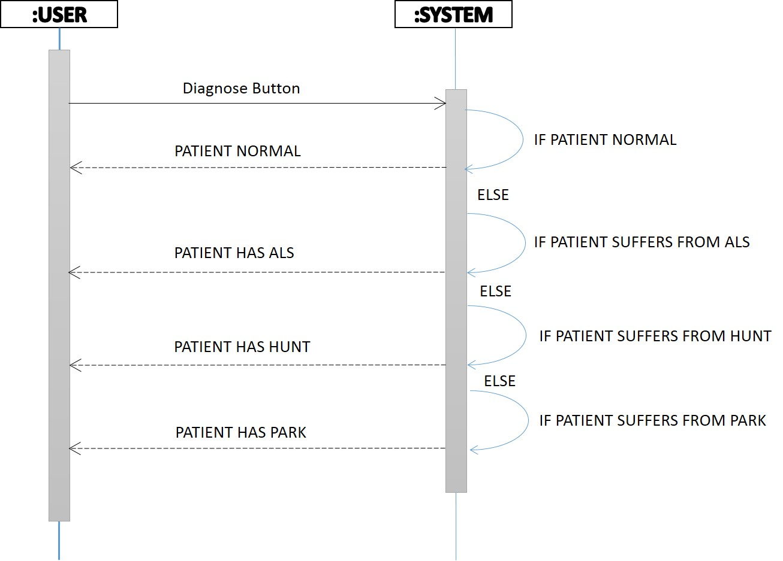**

### 4.10.7 Patient Status

**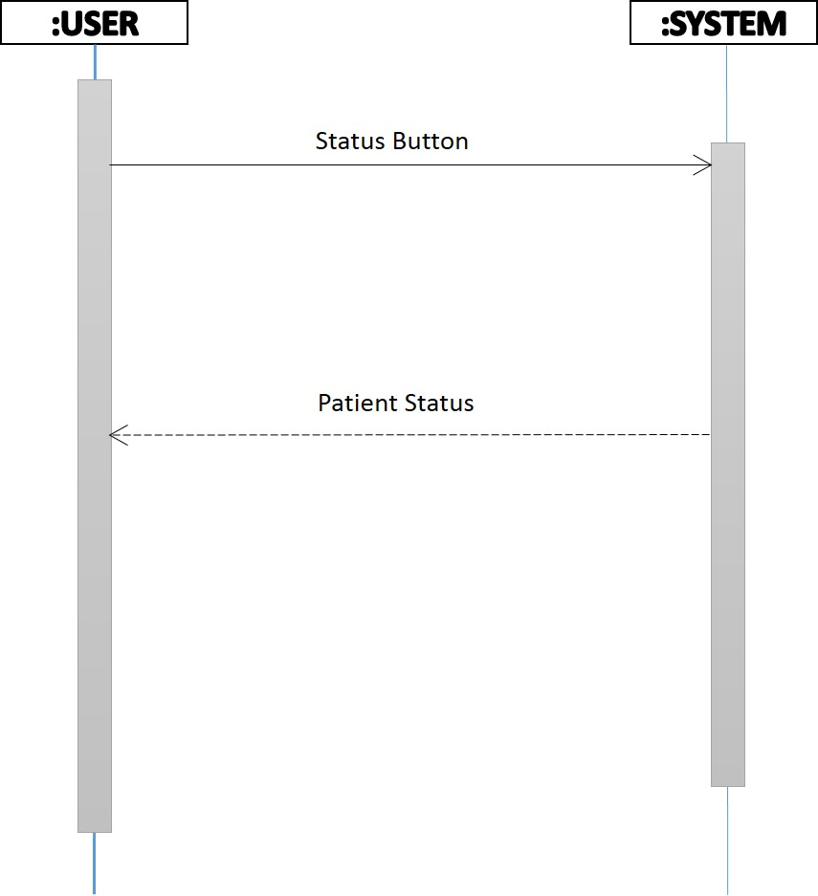**

# Chapter 5

# Implementation

#### 5.2 Formulas used in Application:

#### Mean Formula:

Eq. (1)

#### \bar{x} = \frac{1}{n}\cdot \sum_{i=1}^n{x_i}

For example, the arithmetic mean of five values: 4, 36, 45, 50, 75 is

\frac{4 + 36 + 45 + 50 + 75}{5} = \frac{210}{5} = 42.

#### Standard Deviation:

#### Eq.(2)

#### s = \sqrt{\frac{1}{N-1} \sum_{i=1}^N (x_i - \overline{x})^2}.

#### Eq.(3)

http://standard-deviation.appspot.com/images/standard-deviation-2.png

Where

S= the standard deviation

X=each value in sample

x’= the mean of the values

n = the number of values (the sample size)

The rest of this example will be done in the case where we have a sample size of 5 pirates therefore we will be using the standard deviation equation for a sample of a population. [[2](#_REFERENCES_1)]

Here are the amounts of gold coins the 5 pirates have:

4, 2, 5, 8, 6.

Now, let's calculate the standard deviation:

1. Calculate the mean:

http://standard-deviation.appspot.com/images/mean-def-1.png

http://standard-deviation.appspot.com/images/mean-def-2.png

http://standard-deviation.appspot.com/images/mean-def-3.png

http://standard-deviation.appspot.com/images/mean-def-4.png

2. Calculate http://standard-deviation.appspot.com/images/x-x.png for each value in the sample:

http://standard-deviation.appspot.com/images/x1-x1.png

http://standard-deviation.appspot.com/images/x2-x1.png

http://standard-deviation.appspot.com/images/x3-x1.png

http://standard-deviation.appspot.com/images/x4-x1.png

http://standard-deviation.appspot.com/images/x5-x1.png

3. Calculatehttp://standard-deviation.appspot.com/images/sumx-x.png

http://standard-deviation.appspot.com/images/sumx-x1.png

http://standard-deviation.appspot.com/images/sumx-x2.png

http://standard-deviation.appspot.com/images/sumx-x3.png

4. Calculate the standard deviation:

http://standard-deviation.appspot.com/images/standard-deviation-2.png

http://standard-deviation.appspot.com/images/sdans1.png

http://standard-deviation.appspot.com/images/sdans2.png

**The standard deviation for the amounts of gold coins the pirates have is 2.24 gold coins.**

## 5.2 System Architecture

The basic idea of our system is to design a system by the help of which we can analyze the walking style of human being and we can determine the gait diseases in the person and by the help of this system we can provide the facility to the people who can’t afford the expensive treatment of the gait diseases. In our system we are using data collected by the force resistor sensors. By utilizing this data we can compare the patients data with the data present in our system and then we can get the results and information about the disease. [[3](#_REFERENCES_1)]

## 5.2 Software Components

The Gait Analysis Application Consist of two main parts; desktop application and the hospital generated gait patient data files which are used for the analysis of the Gait disease and through which the Application will make the decision. [[2](#_REFERENCES_1)] The desktop application is dependent on these Textual Gait Patient Data Files other than the system/application will not work.

### 5.3 Tools Used

Tools and technologies used during the implementation of this project are following

* MATLAB
* Visual Studio 12.0
* Microsoft Office

### 5.4 Developer Tools

* Adobe Photoshop
* Visual Studio 12.0
* Microsoft Office

## **5.4.1 Programming Languages**

* C#
* C++
* C

## 

## **5.4.2 MS Office**

* For documentation

### **5.4.3** Spiral Team

### For the project plan and schedule and tracking of requirements

## Main Menu:

### 5.5.1 Description

This is the launching window of the application. In which you can see the main menu of the gait analysis application including step 1, step 2, show result, browse files, and report

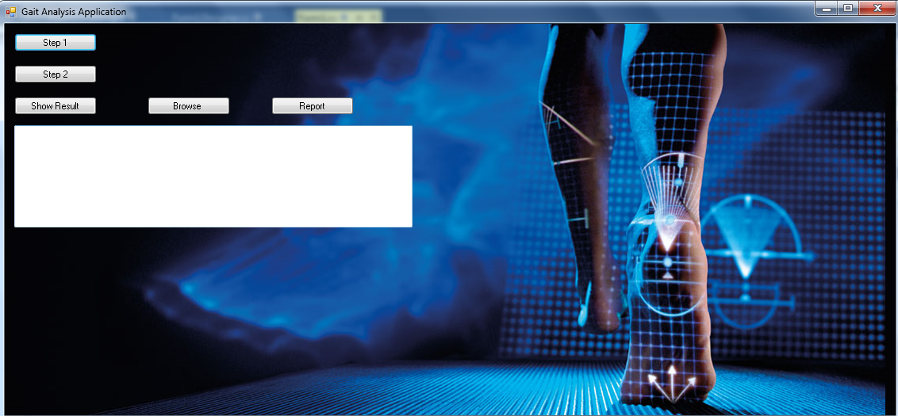

### 5.6 By clicking Step 1

### 5.6.1 Description

By clicking on the step 1 button our system will calculate the mean of the data given to the system by the text file.

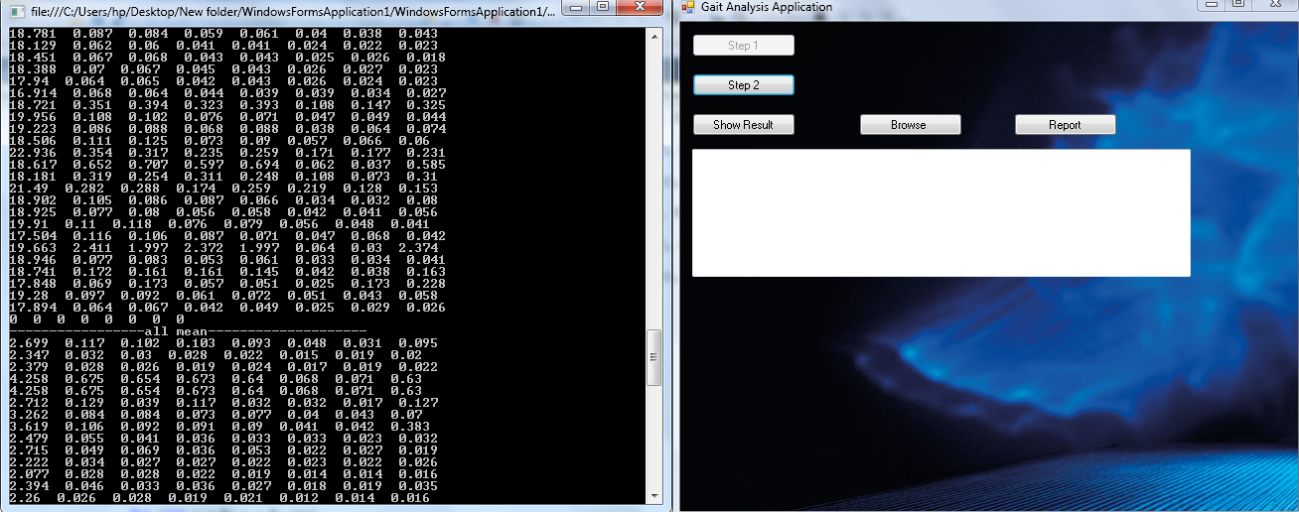

### 5.7 By clicking on Show result

### 5.7.1 Description

**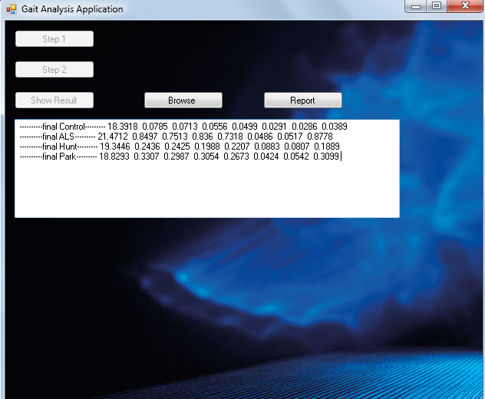**

### 5.8 By clicking on Browse

### 5.8.1Description

By clicking on the browse button we can select the text file from the data folder

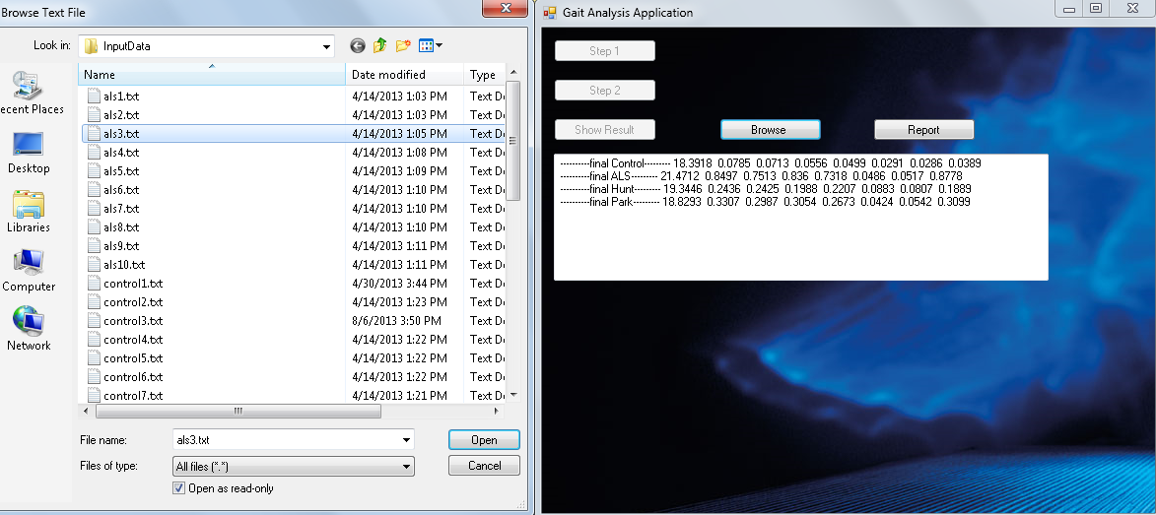

### 5.9 By clicking on the Report button

### 5.9.1 Description

By clicking on the report button we can generate the patients report telling disease

**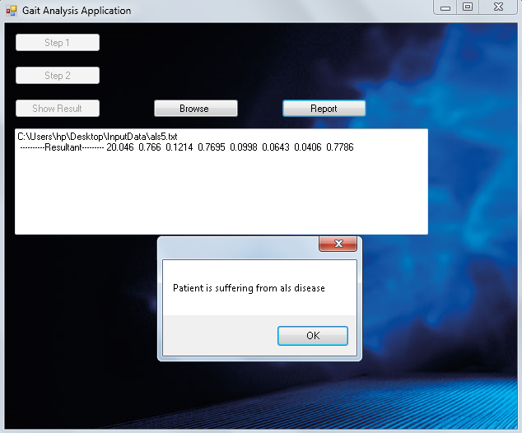**

# 

# Chapter 6

# System Testing and Evaluation

### 6.1 Test Cases

Testing is extremely important, both to ensure that the system meets requirements and to ensure that it is free of errors. That is why it is performed throughout the development process at every level.

### 6.1.1 Analysis Phase

|  |  |
| --- | --- |
| **Test Case ID** | **Test 1** |
| **Objective** | To perform Analysis on the gait data. |
| **Environment** | Windows |
| **Prerequisite** | Application must be run. |
| **Method** | 1. Click on ‘step 1’ button 2. Application will perform the analysis on data. 3. Application will compute difference, mean, deviation etc... For Analysis. |
| **Expected Results** | **Button ‘Step 1’ should disable** |
| The system should perform the analysis on the press of ‘Step 1’ Button. | Pass |

##### Table 6.1.1 Analysis Phase

### 

### 6.1.2 Result Generating Phase

|  |  |
| --- | --- |
| **Test Case ID** | **Test 2** |
| **Objective** | This will generate Final Result based on Analysis. |
| **Environment** | Windows |
| **Prerequisite** | Step 1 must be performing. |
| **Method** | 1. Click on ‘step 2’ button 2. Application will generate the results bases on analysis which will used further on taking decisions. |
| **Expected Results** | **Button ‘Step 1’ should disable and Button ‘Step 2’ should also be disable** |
| The system should generate result on ‘Step 2’ Button press. | **Status:** Pass |

##### Table 6.1.3 Result Generating Phase

### 

### 6.1.3 If the Step 1 Button won’t be pressed

|  |  |
| --- | --- |
| **Test Case ID** | **Test 3** |
| **Objective** | This will generate Final Result based on Analysis. |
| **Environment** | Windows |
| **Prerequisite** | Step 1 must be perform. |
| **Method** | 1. Click on ‘step 2’ button 2. Application will generate the results bases on analysis which will used further on taking decisions. |
| **Expected Results** | **Button ‘Step 1’ should disable and Button ‘Step 2’ should also be disable** |
| The system should through exception if the ‘Step 2’ Button should not be pressed. | **Status:** Fail |

##### Table 6.1.3If Button not pressed

### 

### 6.1.4 Result Display True Case

|  |  |
| --- | --- |
| **Test Case ID** | **Test 4** |
| **Objective** | This will display Final Result. |
| **Environment** | Windows |
| **Prerequisite** | Step 1 and Step 2 must be perform. |
| **Method** | 1. Click on ‘Show Result’ button 2. Application will display the results bases on analysis which will use further on taking decisions. |
| **Expected Results** | **Will show the results based on Analysis.** |
| The system should display result on ‘show result’ Button press. | Pass |

##### Table 6.1.4 Result Display True Case

### 

### 6.1.5 Result Display False case

|  |  |
| --- | --- |
| **Test Case ID** | **Test 5** |
| **Objective** | This will display Final Result. |
| **Environment** | Windows |
| **Prerequisite** | Step 1 and Step 2 must be perform. |
| **Method** | 1. Click on ‘Show Result’ button 2. Application will display the results bases on analysis which will used further on taking decisions. |
| **Expected Results** | **Will show the results based on Analysis.** |
| The system should not display result on ‘show result’ Button press if the step 1 and step 2 won’t perform. | Fail |

##### Table 6.1.5 Result Display False Case

### 

### 6.1.6 File Upload Success Case

|  |  |
| --- | --- |
| **Test Case ID** | **Test 6** |
| **Objective** | It will upload the file of which the disease has to be diagnose. |
| **Environment** | Windows |
| **Prerequisite** | Step 1 and Step 2 must be performing. |
| **Method** | 1. Click on ‘Browse’ button 2. Application will open the open file dialog through which user can add his/her gait data file. |
| **Expected Results** | **Path of the gait data file will be show.** |
| The path of file will be shown on the output box. | Pass |

##### Table 6.1.6 File Upload Success Case

### 6.1.7 File Upload False Case

|  |  |
| --- | --- |
| **Test Case ID** | **Test 7** |
| **Objective** | It will upload the file of which the disease has to be diagnosed. |
| **Environment** | Windows |
| **Prerequisite** | Step 1 and Step 2 must be performing. |
| **Method** | 1. Click on ‘Browse’ button 2. Application will open the open file dialog through which user can add his/her gait data file. |
| **Expected Results** | **Path of the gait data file will be show.** |
| The application will through exception if the file path will not be uploaded. | **Status :**Fail |

##### Table 6.1.7 File Upload False Case

### 6.1.8 Disease Diagnose

|  |  |
| --- | --- |
| **Test Case ID** | **Test 8** |
| **Objective** | Diagnose the status/disease of the patient. |
| **Environment** | Windows |
| **Prerequisite** | Step 1 and Step 2 must be perform. |
| **Method** | 1. Click on ‘Report’ button 2. Application will tell the status of the patient gait data file. |
| **Expected Results** | **The status of patient would be Normal, Als, Park or hunt.** |

##### Table 6.1.8 Disease Diagnose Case

### 6.1.9 Status of Patient when provided the normal patient gait data

|  |  |
| --- | --- |
| **Test Case ID** | **Test 9** |
| **Objective** | Diagnose the status/disease of the patient. |
| **Environment** | Windows |
| **Prerequisite** | Step 1 and Step 2 must be perform. |
| **Method** | 1. Click on ‘Report’ button 2. Application will tell the status of the patient gait data file. |
| **Expected Results** | **The status of patient must be normal.** |

##### Table 6.1.9 Status of Normal Patient Case

### 

### 6.1.10 Normal Patient Data False Acceptance

|  |  |
| --- | --- |
| **Test Case ID** | **Test 10** |
| **Objective** | The status of Control 2 and Control 5 would not be normal because these two gait data files does not meet the threshold criteria. There will be a False acceptance in the application. |
| **Environment** | Windows |
| **Prerequisite** | Step 1 and Step 2 must be perform. |
| **Method** | 1. Click on ‘Report’ button 2. Application will tell the status of the patient gait data file. |
| **Expected Results** | **The status of patient will be park, als or hunt.** |

##### Table 6.1.10 Normal Patient Data False Acceptance Case

### 6.1.11 ALS patient data False Acceptance

|  |  |
| --- | --- |
| **Test Case ID** | **Test 11** |
| **Description** | The status of ALS 1, ALS 2, ALS 8 and ALS 10 would not be in ALS because these gait data files does not meet the threshold criteria. |
| **Environment** | Windows |
| **Prerequisite** | Step 1 and Step 2 must be perform. |
| **Method** | 1. Click on ‘Report’ button 2. Application will tell the status of the patient gait data file. |
| **Expected Results** | **The status of patient may be in normal, PARK or in HUNT category.** |

##### Table 6.1.11 ALS Patient Data False Acceptance Case

### 6.1.12 ALS Patient data success case

|  |  |
| --- | --- |
| **Test Case ID** | **Test 12** |
| **Objective** | Diagnose the status/disease of the patient. |
| **Environment** | Windows |
| **Prerequisite** | Step 1 and Step 2 must be perform. |
| **Method** | 1. Click on ‘Report’ button 2. Application will tell the status of the patient gait data file. |
| **Expected Results** | **The status of patient must be ALS.** |

##### Table 6.1.12 ALS Patient Data Success Case

### 6.1.13 HUNT Patient Data Success Case

|  |  |
| --- | --- |
| **Test Case ID** | **Test 13** |
| **Objective** | Diagnose the status/disease of the patient. |
| **Environment** | Windows |
| **Prerequisite** | Step 1 and Step 2 must be perform. |
| **Method** | 1. Click on ‘Report’ button 2. Application will tell the status of the patient gait data file. |
| **Expected Results** | **The status of patient must be HUNT.** |

##### Table 6.1.13 HUNT Patient Success Case

### 6.1.14 HUNT Patient Data False Acceptance

|  |  |
| --- | --- |
| **Test Case ID** | **Test 14** |
| **Description** | The status of HUNT 2, HUNT 3, HUNT 4, HUNT 6 and HUNT 9 would not be in HUNT because these gait data files do not meet the threshold criteria. |
| **Environment** | Windows |
| **Prerequisite** | Step 1 and Step 2 must be performing. |
| **Method** | 1. Click on ‘Report’ button 2. Application will tell the status of the patient gait data file. |
| **Expected Results** | **The status of patient may be in normal, PARK or in ALS category.** |

##### Table 6.1.14 HUNT patient data false acceptance

#### 6**.1.15 PARK Patient data success case**

|  |  |
| --- | --- |
| **Test Case ID** | **Test 15** |
| **Objective** | Diagnose the status/disease of the patient. |
| **Environment** | Windows |
| **Prerequisite** | Step 1 and Step 2 must be perform. |
| **Method** | 1. Click on ‘Report’ button 2. Application will tell the status of the patient gait data file. |
| **Expected Results** | **The status of patient must be PARK.** |

##### Table 6.1.15 PARK Patient Data Success Case

# Chapter 7

# CONCLUSION

### 7.1 CONCLUSION

The main objective of the project is to provide an automated, very effective and user friendly solution to the users. All the requirements given by the users are implemented and tested. The system is working successfully.

### 7.2Future Recommendations

When we arrest the criminals and save the different data of the criminal steps. If we arrest him again after sometime and compare his steps data with data before enter in this software , the software show him full information of this criminal.

# REFERENCES

[1] *macmillandictionary*. (2006, january 1). Retrieved april 21, 2017, from macmillandictionary: https://www.macmillandictionary.com/dictionary/british/threshold[1]

[2] *merriam*. (2006, januaru 1). Retrieved february 3, 2006, from https://www.merriam-webster.com/dictionary/threshold[2]

[3] *Recognition of gait using computer dynography*. (2008, dec 5). Retrieved april 21, 2017, from *publmed.gov: https://www.ncbi.nlm.nih.gov/pubmed/19218644[3]*

[4] *Stance Phase of Gait*. (2008, march 26). Retrieved november 05, 2017, from wheelessonline: http://www.wheelessonline.com/ortho/stance\_phase\_of\_gait[4]